Engineering Spec



OAOA – Rich Client
(WBXxxxxxx)

WebEx Confidential Information
This document contains confidential information belonging to WebEx Communications, Inc. ("WebEx"). You cannot access this document unless you are a WebEx employee and have been expressly authorized by your supervisor to have such access. You cannot disclose, copy, display, or otherwise communicate the contents of this document except to other WebEx employees who have been authorized to access the document
Revision history
Date | Authors | Contributors | Description
2009-5-1 | Nick Xiao |  | 1st Draft
2009-5-19 | Nick Xiao |  | Add wapi request and timing graph.

Introducation

Goals and objectives
In previous design, rich client have to make a bunch of WAPI calls to get enough information to render the UI. This process is time consuming and leads bad experience for users.
In C6, we’re going to improve the usability by consolidate WAPI calls.
There’re 3 aspect gets involved in this task.

Login
ListWorkspace
LoadWorkspace

Reference Link
Table 1.1-1 Table of Reference Link
Document | Owner | DMS #
Connect Performance-C6-WAPI ListWorkspace Specification | Yoland yao

Major Changes

New design

Login

overview

Currently in C5.1/6, the calls client made when login are listed below:

1. get username/password from SSO if enabled.
2. if SSO disabled, username/password is provided by user.
3. login WAPI
4. check auto upgrade
5. get config info
6. get premium service info
7. get policy info
8. get space list
9. get space invite
10. get favorite space list

The calls client is going to make in the new design are:

1. get username/password from SSO if enabled.
2. if SSO disabled, username/password is provided by user.
4. login WAPI
5. get initial config and check auto upgrade
6. get addtional config
7. get favorite space list
8. get space list (including space invite) (called when space tab being clicked)

Timing
This section is added for the requirements from QA.
The durations are measured in local environment, so they may be shorter than in the production environment.
- login:
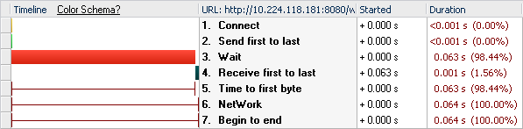
- InitialConfig
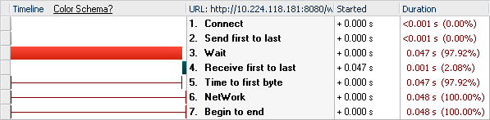
- AdditionalConfig
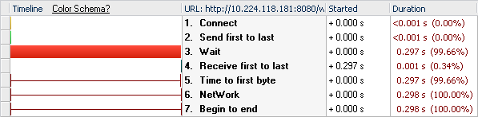
- FavoriteSpaceList
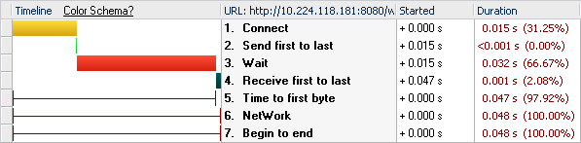

WAPI call requests
1. login
cmd=login&autocommit=true&username=szqa03%40jabber28.webex.com&password=********&isp=WBX

2. InitialConfig
cmd=execute&task=InitialConfig&isp=WBX&xml=<input><returnCACert>true</returnCACert><org><select>namespaceID</select></org><ProbeAccess><AutomaticUpdates/></ProbeAccess></input>

3. AdditionalConfig
cmd=execute&task=AdditionalConfig

4. GetFavoriteSpaceList
cmd=execute&task=FavoriteWorkspaceList

ListWorkspace

Wapi Request
- cmd=execute&task=WorkspaceList
- cmd=execute&task=GetUserLibrariesWithApps&xml=<library><readonly>false</readonly><with><widget>false</widget><topLevelApp>false</topLevelApp></with></library>
- cmd=execute&task=GetResourceStatus&xml=<resources><type>storage</type><level>user</level></resources>

Timing
1. WorkspaceList
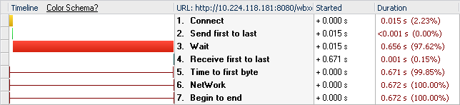
2. GetUserLibrariesWithApps
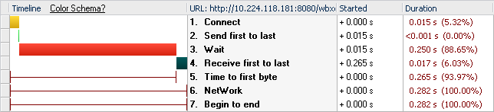
3. GetResourceStatus
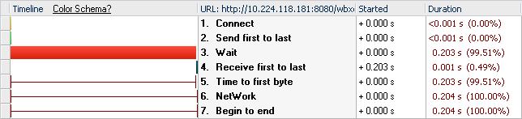

LoadWorkspace

Wapi Request
1. LoadWorkspace
cmd=execute&task=LoadWorkspace&xml=<input><workspace><workspaceID>WB428PSVCASN771DTDUSI8S4V4</workspaceID></workspace></input>

2. ProbeAccess
cmd=execute&task=ProbeAccess&xml=<tests><set-workspace><id>WB428PSVCASN771DTDUSI8S4V4</id></set-workspace><delete-workspace><id>WB428PSVCASN771DTDUSI8S4V4</id></delete-workspace><BulkSpaceInvite/><create-chatRoom/><create-doc/><set-doc/><delete-doc/><create-chatEntry/></tests>

Timing

1. LoadWorkspace
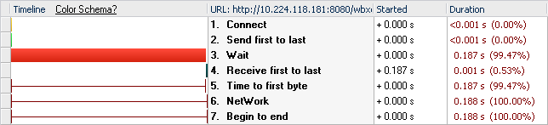
2. ProbeAccess
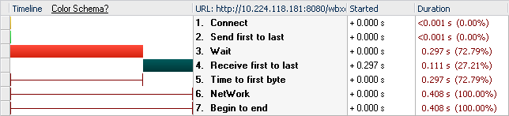

4. Security

4.1 Authentication and authorization

Checklist
Questions | Y / N | If the answer is Y(es), then please provide references
- Does your task involve new user access interface to server, or inter-server, inter-components, inter-Widgets, inter-Space communication channel? | N
- Does your task add new user interfaces or programming interfaces that can performing certain actions, or does your task change the behavior of existing UI or add action flag to existing API? We only care about these action requests that are sent between servers, widgets, Spaces, modules, computers. | N
- Does your task add new web page / URL that used to perform critical and irreversible operations? | N
- Does your task access sensitive information from server or local storage? | N

Authentication and authorization table
Please read checklist section first then follow the instruction to fill this table
UI/API name | Function description | Who (user or program) can access this UI / API? | How to authenticate who the user is?
NA | NA | NA | NA

4.2 Information Privacy and Integrity

Checklist
Questions | Y / N | If the answer is Y(es), then please provide references
Does your task transmit any sensitive data over network? | N
- Does your task save any sensitive data in DB, DMS, or file? | N
- Does your task save any sensitive data in Widget client? | N

Programming security

Checklist
Questions | Y / N | If the answer is Y(es), then please provide references
- Does your task add new UI elements to take inputs from users? | N
- Does your task receive new parameters from network? | N
- Does your widget receive any data from other Widgets? | N
- Does your task output any user input data or network incoming data as part of HTML, JavaScript, VB script, URL, OS shell script, and etc.? | N | .
- Does your task uses new iBatis unbound variable $xxx$ in SQL statements? | N
- Does your task redirect to non-WebEx web site? | N
f.1 Does your task support redirect to any non-WebEx sites? | N
f.2 Does your task support redirect to specific non-WebEx sites? | N
- Does any code of your task will NOT meet WebEx secure coding standard? | N
- Does your task adopt any new Open Source, free or commercial libraries? | N
- Does your task involve any crypto algorithms or key management?  Example:  - Encryption algorithms such as AES, RC4, DES, etc.  - Hash algorithm such as SHA1, SHA2, MD5, etc.  - Crypto token, Session ID and Key generation and storage  - Random number generator | N
- Does your task have compliance requirements? | N

Input validation table
Module name | UI / API name | Parameter / field name | Data type | Legal value description | Min size  (chars) | Max size (chars)

Logging / Audit trail

Checklist
Questions | Y / N | If the answer is Y(es), then please provide references
a. Does your task log any events at server side? | N
a.1 Does the log contains any sensitive information like username, password, meeting key and etc.? | N
b. Does your task log any events at client side, at user's PC? | N
b.1 Does your task contains any sensitive information like username, password, meeting key and etc.? | N

Environment dependency / configuration

Checklist
Questions | Y / N | If the answer is Y(es), then please provide references
a. Does your task need security related file configuration change? | N
- Does your task need security related environment configuration change? | N

